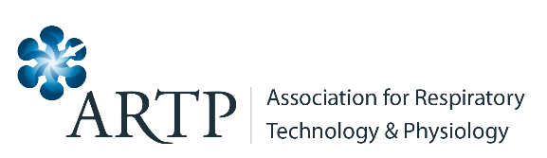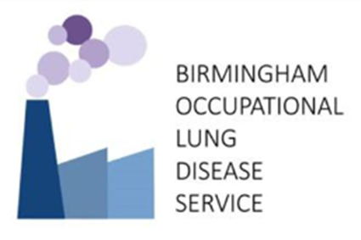

ARTP OCCUPATIONAL ASTHMA COURSE 14th and 15th March 2024
REGISTRATION FORM

Title
First Name
Surname
Job Title
Workplace
Address
Email address
Telephone number

Registration (includes lunch and refreshments during the course) | Amount (£) £
Non-ARTP member Occupational Asthma Course (£350)

ARTP member Occupational Asthma Course (£300)

I am a free candidate from the cancelled 2020 course

Total

PAYMENT INFORMATION

I enclose a cheque in sterling payable to Heartlands Hospital Charity

I will pay online https://www.hospitalcharity.org/shop/product/occupationalasthmacourse2024

Signature of delegate: Date

Please tell us how you heard about the course

Please complete this form and return to Vicky Moore e-mail: vicky.moore@uhcw.nhs.uk

Cancellation Policy
* All cancellations must be received in writing by post or email
* Cancellations before 7th March 2024 will be subject to a £10 administration charge; no refunds after 7th March 2024 will be given.

