Instructions for the Mini-Wright Meter

When to take Readings
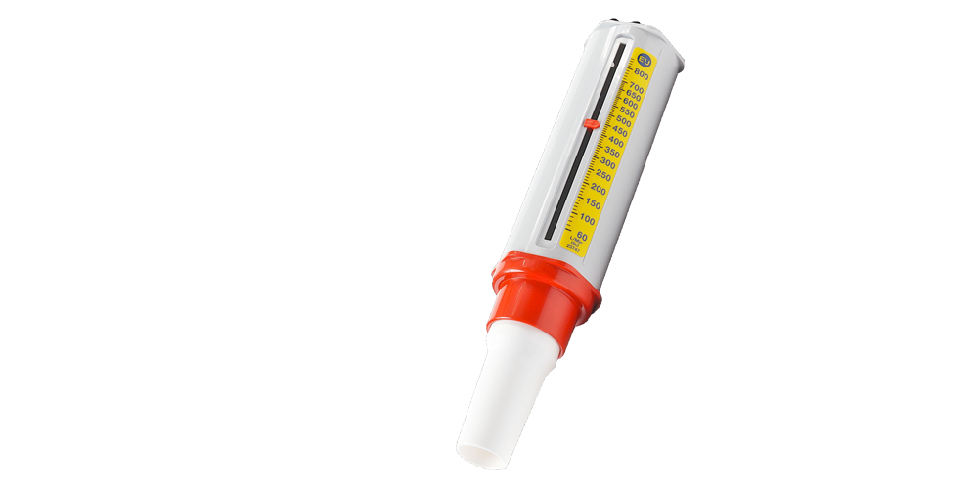
The readings should be taken regularly, whether at work or not for 4 weeks. The readings should be taken on waking and then approximately at two hourly intervals until you go to bed. It is IMPORTANT that you write down the times that you start and finish work each day and the jobs you do each day.

Taking Readings

- Ensure that the white plastic mouthpiece is securely placed into the end of the barrel of the peak flow meter. Set the indicator to Zero.
- Stand or sit in good posture.
- Hold the peak flow meter lightly, with the gauge uppermost and ensure that your fingers are kept away from the gauge.
- Take a deep breath - As Deep As Possible.
- Place the mouthpiece into your mouth and close your lips around it tightly. Blow Out, as Fast and as Hard as possible.
- Make a mental note of your reading i.e. where the arrowhead on the indicator is lying (where each small line = 10 units).
- Return the indicator to Zero again.
- Do this Three or more Times, so that you obtain three close readings (ideally within 20L/min of each other).
- Write down the Highest of your three readings in the correct column onto the chart provided.

Notes
If you need to take your inhaler when it is time to carry out a peak flow reading, do the blow first, then take your inhaler. If you forget to take a reading, take one immediately and then go on to the next one as usual. Please write down on the charts if you have a cold or chest infection.
On Completion
When you have finished taking readings please either post your readings by recorded delivery or hand them in in person. Make sure you keep a photocopy of the charts if posting in case they are lost. Please remember to write down your name, height, date of birth, job, and workplace on all of the charts, in case they are separated.

