1. Please enter the date, the time of waking up and going to sleep and, if working, the time of starting and finishing work.
2. If you are working night shifts please enter the times of starting and finishing work as shown (with AM / PM). We will work out that you actually finish work the next day.
3. It is important to write down the time you wake up and go to sleep, even on days off.
4. If you work in different areas or with different materials please make a note of this each day.
5. Please note your asthma medication on every sheet and on every day you need extra medication.
6. Please make a note if you are ill.
7. The occasional missed reading is not a problem.
8. Taking readings on days off is as important as taking readings on days at work, if not more so.
Always return your cards and meter together. We need both to analyse your record.

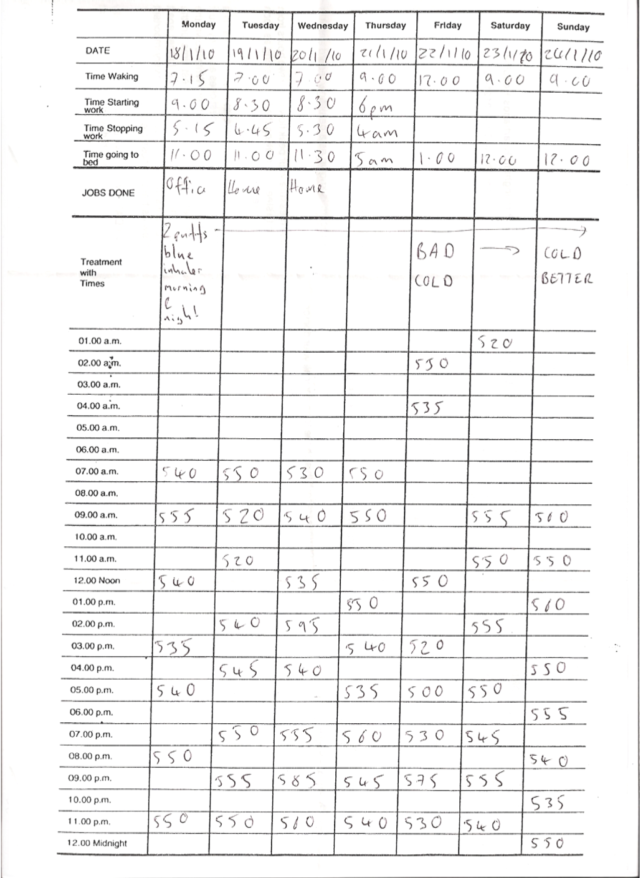
2
1
5
3
4
6
7
8

