Rate of FEV1 decline

Arun Dev Vellore¹, Donatella



in workers with eosinoph

Talini², Wasif Anees¹, Vicky Moore¹,

¹Occupational Lung Disease Unit
Birmingham Heartlands Hospital
Birmingham, United Kingdom

Correspondence: avellore@gmail.com
ilic and non-eosinophilic

Federica Novelli², Pier Luigi Paggiaro²

²CardioThoracic Medicine
University Hospital Pisa
Pisa, Italy

occupational asthma

and Sherwood Burge¹



1. Background: We have previously shown that workers with occupational asthma caused by low molecular weight agents can be divided into those with raised and normal levels of sputum eosinophils, (>2.2%) measured during symptomatic exposure to the causative agent. ¹ Workers with continuing exposure to the causative agent have accelerated FEV₁ decline. ²

2. Aims: To investigate the relationship between FEV₁ decline (ΔFEV₁) and sputum eosinophilia in workers with occupational asthma and continuing exposure to causative agents (both low molecular and high molecular agents) from two centres: Occupational Lung Disease Unit, Birmingham and Dipartimento Cardio Toracico, Università di Pisa, Pisa.

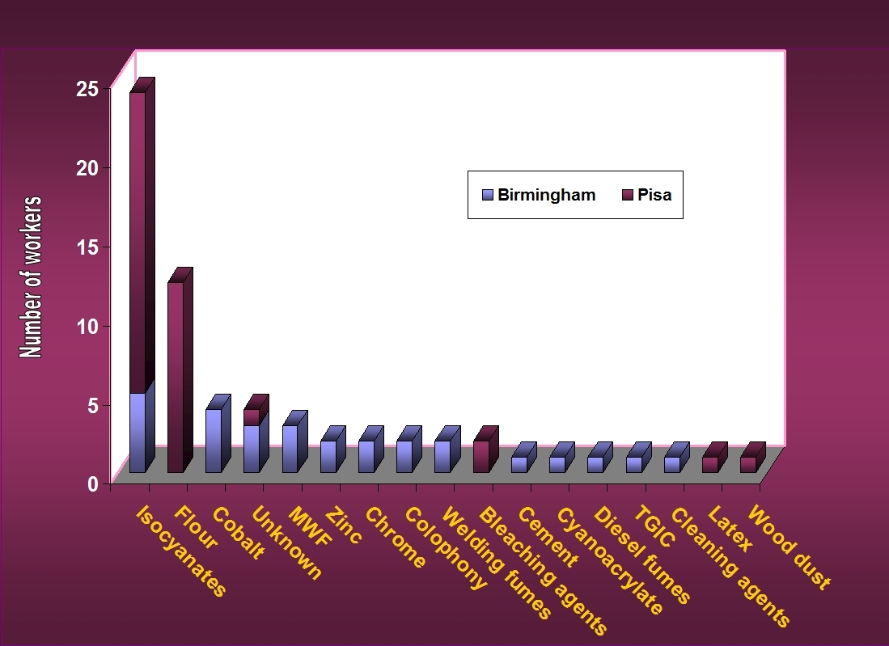
Fig 1: Causative agents
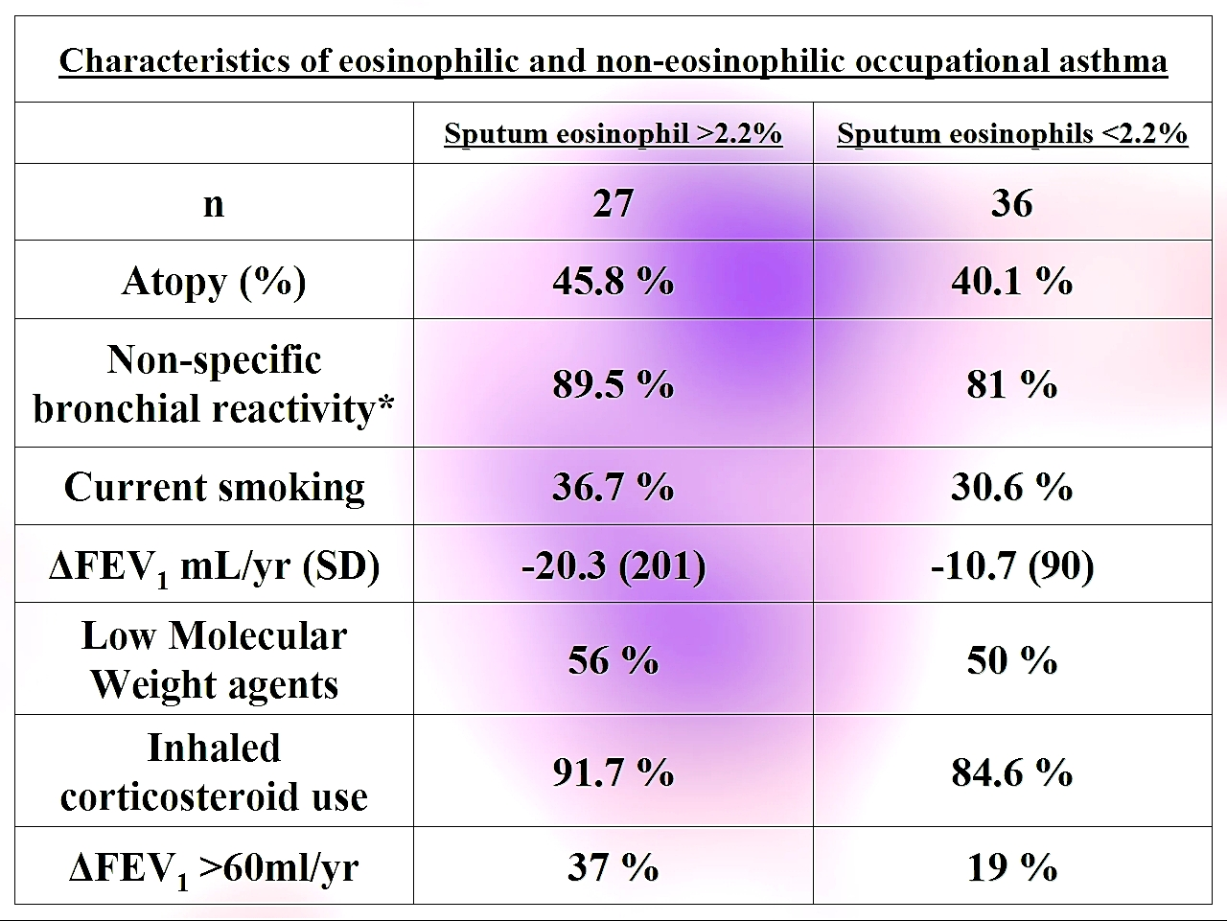Fig 2: Characteristics of the two groups
5. Conclusions: The eosinophilic group as a whole had greater FEV₁ decline compared to the non-eosinophilic group; this group also had a higher number of individuals with a mean annual FEV₁ decline of >60 mL/year. The variance was large however and the mean differences between the groups statistically non-significant. This may suggest that an additional variable, perhaps interacting with eosinophil phenotype, could be affecting the ΔFEV₁.

Longitudinal FEV₁ studies in workers with occupational asthma who tolerate continuing exposure to the causative agent are likely to be biased as a survivor population; those with rapid FEV₁ decline are often unable to continue work due to disability. Larger studies are required to further define the phenotypes.

3. Methods: 63 consecutive workers with occupational asthma from 2 centres were investigated during symptomatic exposure to the causative agents at work with: (1) Sputum induction studies (2) bronchial hyper reactivity measurement and (3) serial FEV₁ measurements for a minimum period of 12 months (mean period 4.69 years; SD 2.96).

ΔFEV₁ during exposure was calculated by linear regression utilising all individual measurements in the eosinophilic and non-eosinophilic groups.

Fig. 1 illustrates the causative agents in the studied workers.

4. Results: 42.5% of the studied workers were atopic; 33.3% were current smokers and, 84.6% exhibited bronchial hyper reactivity (methacholine).

The majority of the patients were on treatment with inhaled corticosteroids (87.6%). Low molecular weight agents were the cause in 52.6% of workers; isocyanates were the single largest group.

The mean annual ΔFEV₁ in the studied workers was -14.8 mL/year. Fig 2 illustrates the characteristics of the workers in the eosinophilic and non-eosinophilic groups and Fig 3, the distribution of mean annual ΔFEV₁ within the groups.

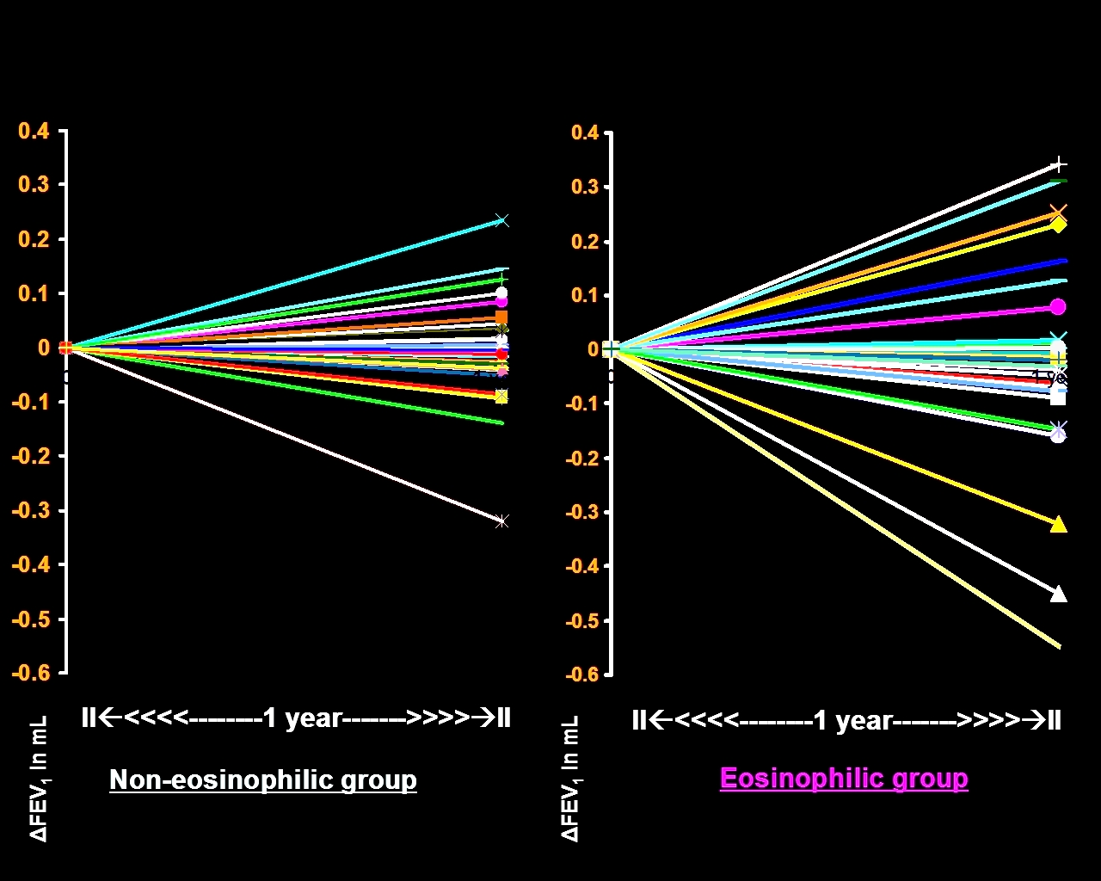
Fig 3: Mean annual ΔFEV₁ in the two groups

References:

1. Anees et al. Occupational asthma due to low molecular weight agents: eosinophilic and non-eosinophilic variants. Thorax 2002; 57:231-236.

2. Anees et al. FEV₁ decline in occupational asthma. Thorax 2006;61:751–5.

_____________

