FEV1 decline in workers

Vellore AD¹,
¹Occupational Lung

`
Background: Continuing workplace exposure to causative agent is associated with a poor prognosis in occupational asthma. Two separate phenotypes have been previously described based on the presence of sputum eosinophilia (>2.2%)¹. Eosinophilic subjects have significantly increased fractional exhaled nitric oxide levels (FE_{NO}) and show higher non-specific bronchial reactivity and bronchodilator reversibility, lower pre-bronchodilator FEV₁, FEV₁/FVC and worse St George Respiratory Questionnaire (SGRQ) scores.
with occupational asthma and

Moore VC¹, Burge CBSG¹, Robertson AS², Anees W³,
Disease Unit, Birmingham ²Selly Oak Hospital, ³Princess Elizabeth

Methods: 51 consecutive workers with occupational asthma who had FE_{NO} measurements and sputum induction studies whilst exposed to the causative agent (Fig 1) were followed up with regular FEV₁ measurements until complete removal from exposure (Minimum follow up period of ≥ 1 year; mean 5.4 yrs, SD 2.92). All workers were advised to avoid continuing exposure at diagnosis. The ΔFEV₁ in the normal and raised FE_{NO} groups was calculated by linear regression analysis using all measurements made over the follow-up period.
normal exhaled NO levels

Burge PS¹
Hospital, Guernsey

Conclusions: Our previous work has showed ΔFEV₁ of 100.9 mL/yr (SEM 17.7) in 90 workers with OA (not phenotyped by FE_{NO}) caused by low molecular weight agents with continuing exposure who were then followed up over a mean of 2.9 yrs.²

In this study, workers with normal FE_{NO} at presentation (with ongoing exposure) shows a FEV₁ decline of 6.9 mL/year over a longer period, suggesting a better prognosis for this group despite continuing exposure to the causative agent (Fig 3).

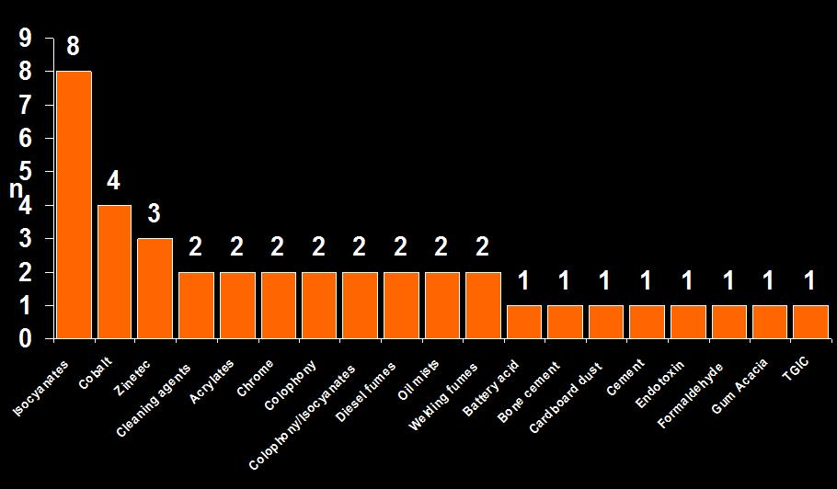

Fig. 1: Distribution of causative agents

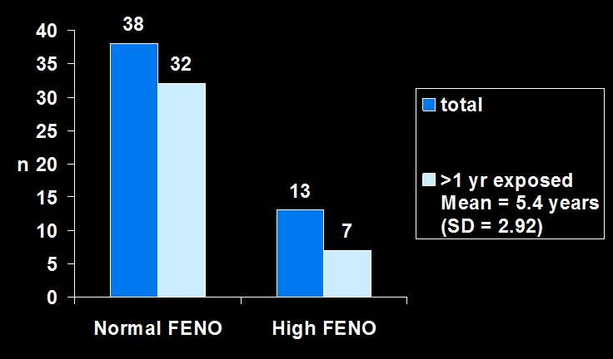

Fig. 2: Distribution of high and low FE_{NO} groups

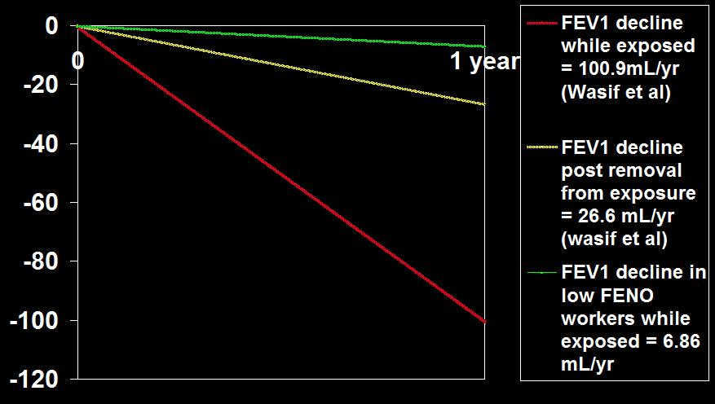

Fig. 3: ΔFEV₁ in normal FE_{NO} group compared to overall ΔFEV₁ in workers with Occupational Asthma. (Y axis = FEV₁ in mL/year)

Aims: To determine whether the rate of FEV₁ decline (ΔFEV₁) is different in a group of workers with occupational asthma who have normal FE_{NO} compared to those with raised FE_{NO} measurements . (Logan® 2000; +/- 9.6 ppb at flow of 200 L/min).

We postulated that the rate of FEV₁ decline during continued exposure would be less in those with normal FE_{NO} measurements at presentation compared to those with raised FE_{NO}.

Results: In the normal FE_{NO} group (n=38) which was predominant, only 5/32 (15.6%) had ΔFEV1 > -60 mL/year compared to the high FE_{NO} group (5/7, 71.4% had Δ FEV₁ > -60 mL/year).

Mean ΔFEV₁ in the normal FE_{NO} group was -6.86 mL/year (95% CI, -0.041 to 0.028); only 7 out of 13 workers with raised FE_{NO} at presentation remained exposed for >1yr before complete removal from exposure, making ΔFEV₁ assessment and statistical analysis unreliable in this group (Fig 2).

Conclusions (continued): However, higher dropout rates in workers with rapid FEV₁ decline in general needs to be considered.
_____________________________________________________

References:

- Anees et al. FEV1 decline in occupational asthma. Thorax 2006;61:751–5
- Anees et al. Occupational asthma due to low molecular weight agents: eosinophilic and non-eosinophilic variants. Thorax 2002; 57:231-236.

